**Software Testing Life Cycle**

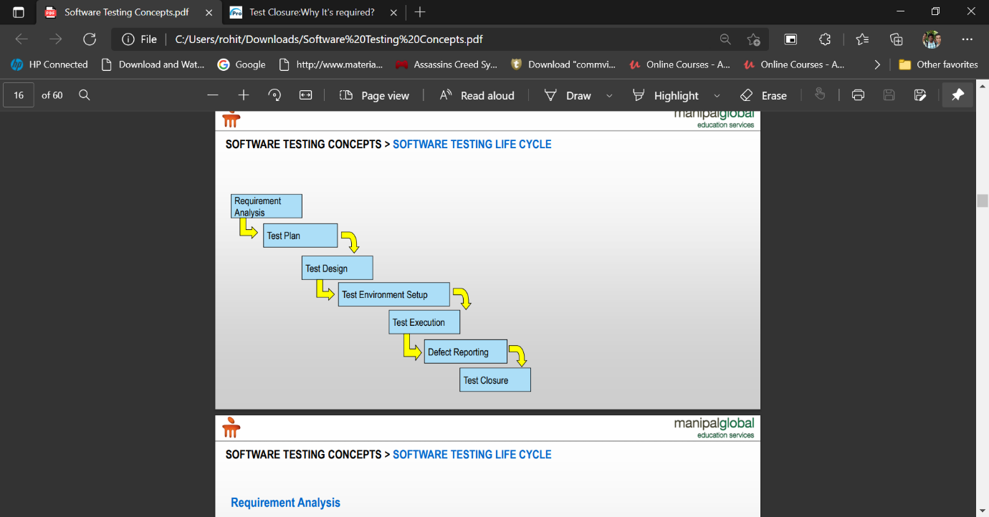

STLC stands for Software Testing Life Cycle.

**Entry Criteria:**

Entry Criteria for STLC phases can be defined as specific conditions; or, all those documents which are required to start a particular phase of STLC should be present before entering any of the STLC phase.

**Exit Criteria:**

Exit Criteria for STLC phases can be defined as items/documents/actions/tasks that must be completed before concluding the current phase and moving on to the next phase.

**REQUIREMENT ANALYSIS:**

Requirement Analysis is the first phase of STLC and it starts as soon as the SRD/SRS is shared with the testing team. Let us consider the following points to understand the Requirement Analysis in STLC.

* The entry criteria of this phase are the provision of SRS (Software Requirement Specification); it is also recommended that the application architecture is handy.
* In this phase, the QA team analyses at a higher level what to test and how to test.
* The QA team follows up with various stakeholders like Business Analyst, System Architecture, Client, Test Manager/Lead in case any query or clarification is required to understand the requirement.
* Requirements may be functional or non-functional like performance, security, usability, etc. or both functional and non-functional.

· The exit criteria of this phase are to complete the RTM document, automation feasibility report and a list of questions if applicable to be more specific on the requirements.

PROBLEM STATEMENT:

* Availability
* Time
* Cost
* Address
* Notification
* Pickup

**TEST PLAN**

**Planning**

Based on the requirements, test lead creates the test plan document.

Test Plan is a document that contains the objectives, scope of testing, Approach to be followed, Schedule, Roles and Responsibilities.

Activities in Test Plan:

1. Test Lead creates the test plan deliverable according to ADM standards

2. Test Effort Estimation

3. Determine roles and responsibilities

**Test Design**

The Test Case Design/Development Phase involves the creation, verification and rework of test cases & test scripts after the test plan is ready. Initially, the [Test data](https://www.guru99.com/software-testing-test-data.html) is identified then created and reviewed and then reworked based on the preconditions. Then the QA team starts the development process of test cases for individual units.

Test development implies using manual and automated testing to achieve full coverage of the software’s functionality, with the process being based on the requirements set up beforehand.

Test Case Development Activities

* + Create test cases, automation scripts (if applicable)
  + Review the test cases and scripts
  + Create test data (If Test Environment is available)

**Test Environment Setup**

* Test Environment Setup is one of the critical aspects of testing process.
* Test Environment decides the software and hardware conditions in which the software is tested.

**Activities in Test Environment Setup**

* Depending on the type of test, tester prepares the hardware and software requirement list.
* Understand the test requirements thoroughly and educate the test team members.
* Check for the required hardware and software, licenses.

**Hardware:**

* Intel core i3 or above.
* Ram 4gb or above.
* Any operating system:
* Example: windows 7 and above

**Software:**

* Apache JMeter.
* Technical team setup the test environment.
* Testers perform readiness test on the test environment to ensure that the environment is ready to perform testing

**Defect Reporting:**

* Defect reporting is the process of identifying defects in an application by testing and reporting to the development team.
* The defects are documented in a deliverable called system investigation request (SIR).

Activities in Defect reporting:

* Testers compare the expected and the actual results of each test step in test scrip deliverable.
* Tester's log defects if there is discrepancy.

**Test Cycle Closure**

Test Closure is a document that gives a summary of all the tests conducted during the software development life cycle it also gives a detailed analysis of the bugs removed and errors found. Test closure is a memo that is prepared prior to formally completing the testing process. The memo contains a report of test cases executed, type and number of defects found, the density of defects etc.

* Test Cycle Closure Activities
* Evaluate cycle completion criteria based on Time, Test coverage, Cost, Software, Critical Business Objectives, Quality
* Prepare test metrics based on the above parameters.
* Test leads prepares the test closure memo

**Implementation**

Requirement Analysis:

1. Availability of products
2. Rent Duration
3. Cost of delivery
4. Address to be delivered
5. Notification in case an App is required
6. Pickup

Suggested testing techniques – 1. Dynamic and manual testing

2. Static and Automated Testing

Test Plan:

Test Plan is a document that contains the objectives, scope of testing, Approach to be followed, Schedule, Roles and Responsibilities.

Test Design:

Preparation of Test data, test cases

Test Environment Setup:

If we are going to add the required changes (rental module) to a website an i3 processor with 4GB RAM would be more than sufficient. In case an app is required i5 processor will suffice.

Defect Reporting:

Defects could include handle OTP being generation, handle scalability issues.

Test Closure:

